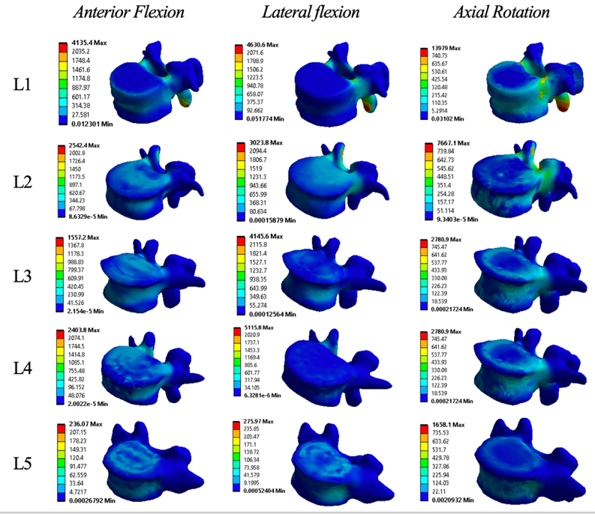
Figure 4a. Von Mises stress of vertebral body in patient 1.
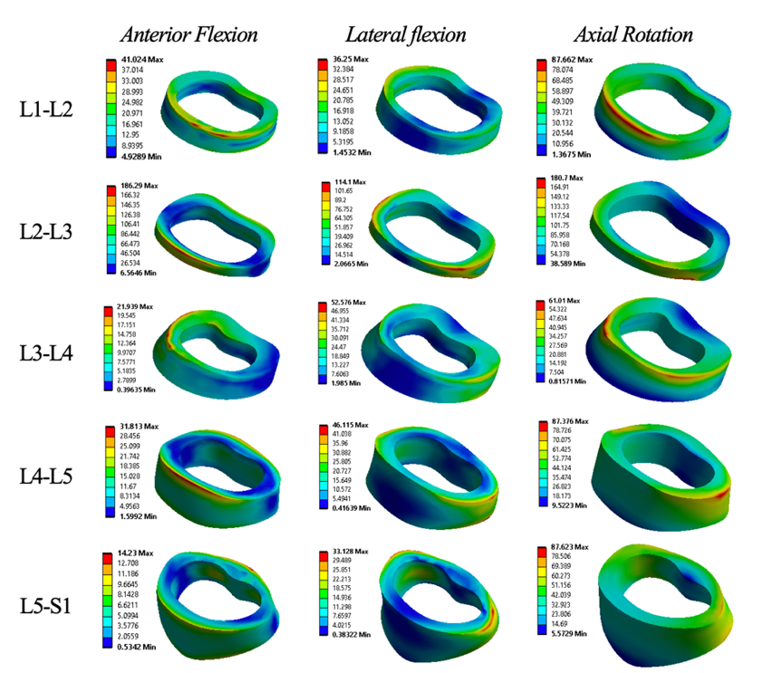
Figure 4b. Von Mises stress of annulus fibrosus in patient 1.
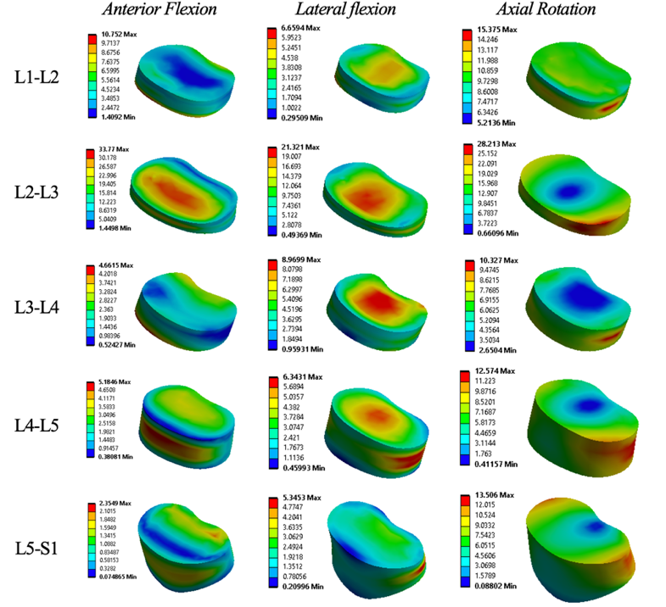
Figure 4c. Von Mises stress of nucleus pulposus in patient 1.

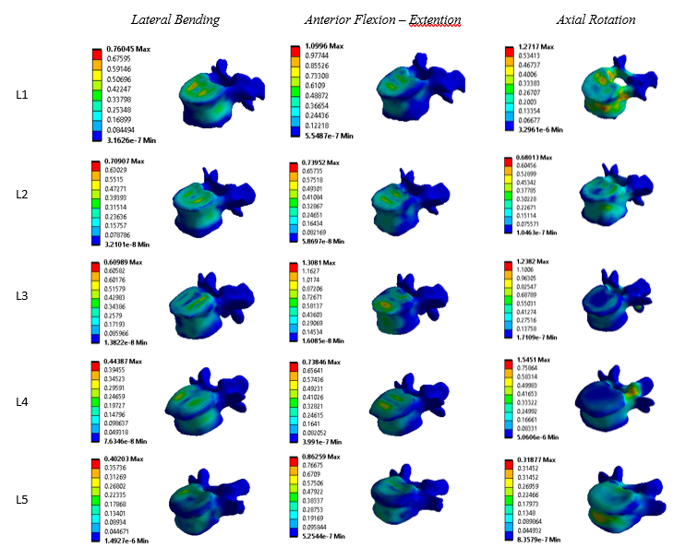
Figure 5a. Von Mises stress of vertebral body in patient 2.

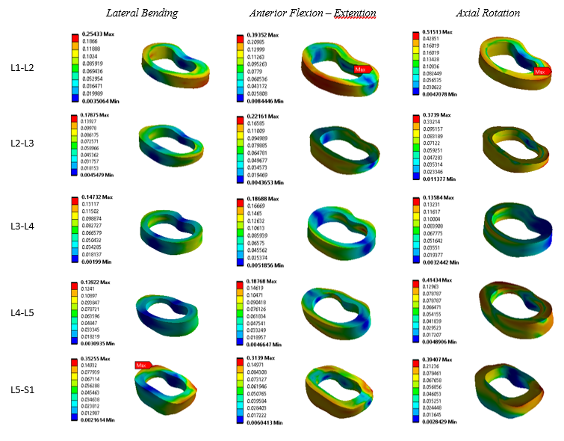
Figure 5b. Von Mises stress of annulus fibrosus in patient 2.

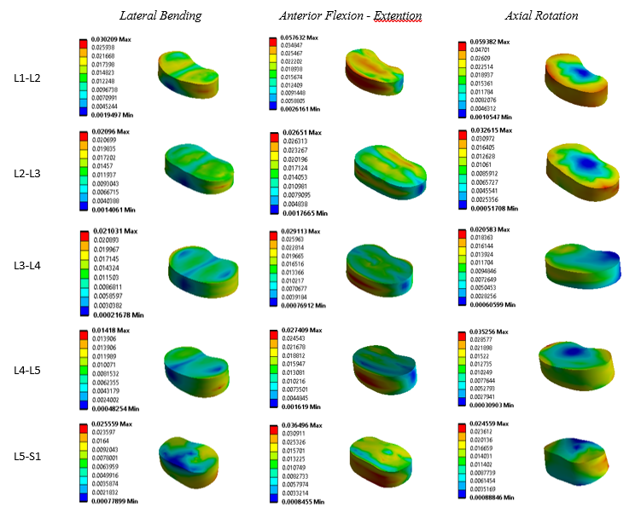
Figure 5c. Von Mises stress of nucleus pulposus in patient 2.

